**Issues while imaging**

When you begin imaging, you may encounter various sheets where mounting makes it difficult to capture images. Ideally, we would remove all sheets needing remounting, but that is too time-consuming and not the objective of the DaSSCo project.

The general rule is that all specimens must be barcoded and imaged. If necessary, they should be flagged in the app if they require further attention. It is then up to the collections managers to assess the flagged specimens later on. Furthermore, Herbarium Sheets should always be handled with great care, which effectively means that we do not open any capsules or folded/layered sheets.

The most common problems include an obstructed view of label information and/or specimens. In this document, you will find examples of the problematic sheets we have encountered so far and how to

1. **Glued or folded regular** 
   1. Folded with no information or specimen on the first sheet
   2. Image: Turn the sheet upside down so the sheet doesn’t cover the targets/scale and image as normal.

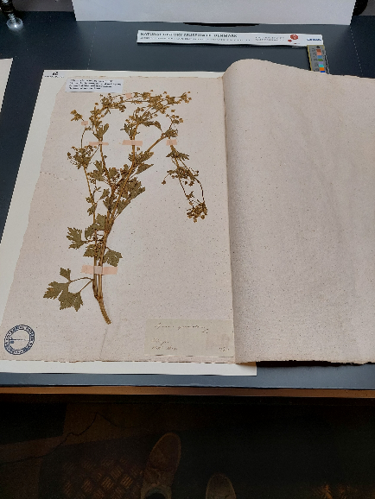

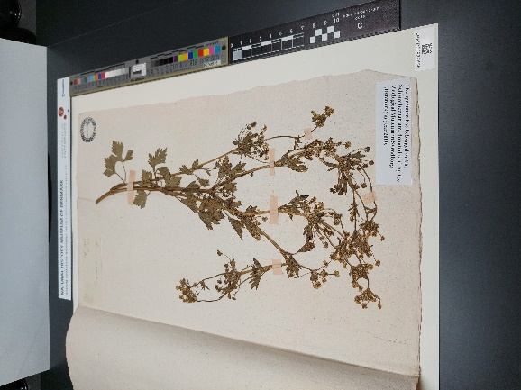

* 1. Top or side glued layered sheets with all label information on the top sheet (or same label information on both sheets).
     1. Barcodes: Assign barcodes to the number of specimens represented by labels on the TOP sheet.
     2. Flag as: single/MSO[1]
     3. Note: Specimen obscured. If you flagged the object as an MSO only note this on specimen(s) NOT showing on the front page.
     4. Image: front page only.

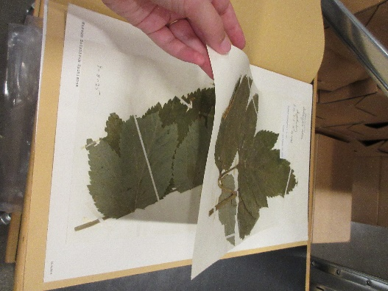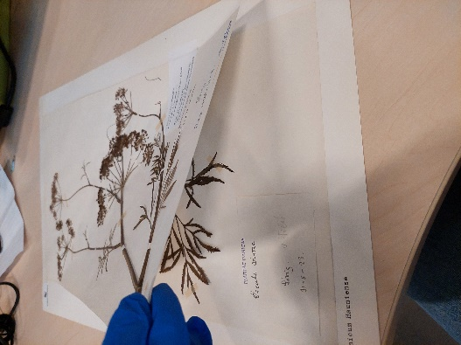

* 1. Folded/layered with no visible labels: Any type of layered sheets with all label information on bottom OR the backside of the sheets.
     1. Barcode: Place a single barcode on the front sheet.
     2. Flag as: single
     3. Check box: Specimen obscured; Label obscured
     4. Image: Front page only

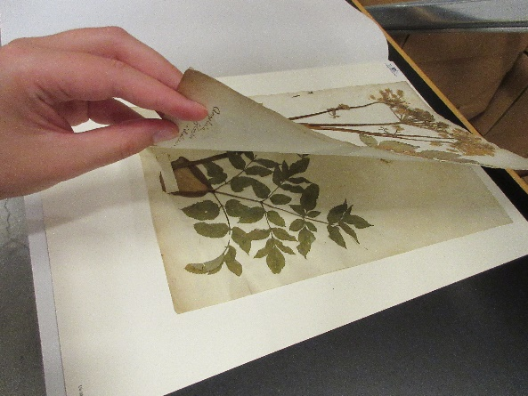 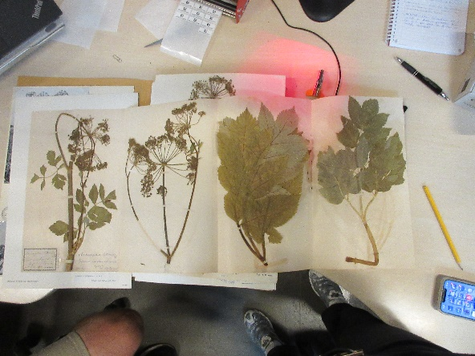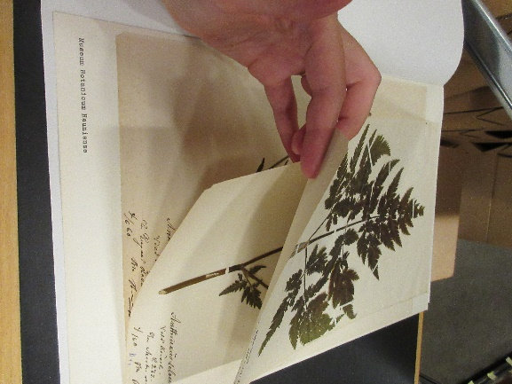

* 1. Opposite side glued layered sheets with all information on the bottom sheet.
     1. Barcode: 1
     2. Flag as: single
     3. Check box: Specimen obscured; Label obscured
     4. Image: Front page only

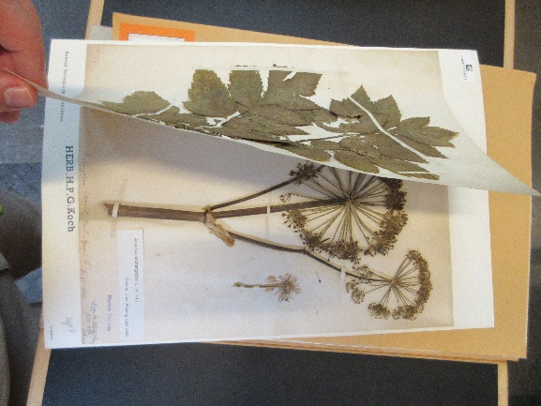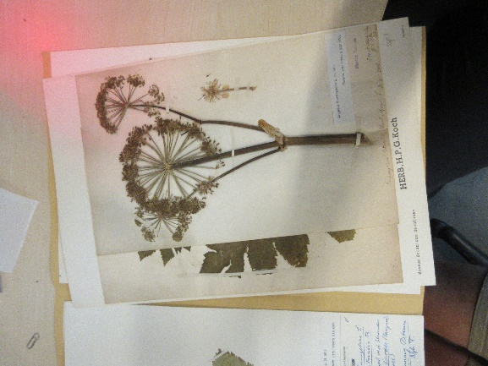

* 1. Any type of folded sheets that show more than one label with the **same** information when folded
     1. Barcodes: 1
     2. Flag as: single (as they are glued together this is not a MOS)
     3. Check box: Specimen Obscured
     4. Image: as regular sheet.

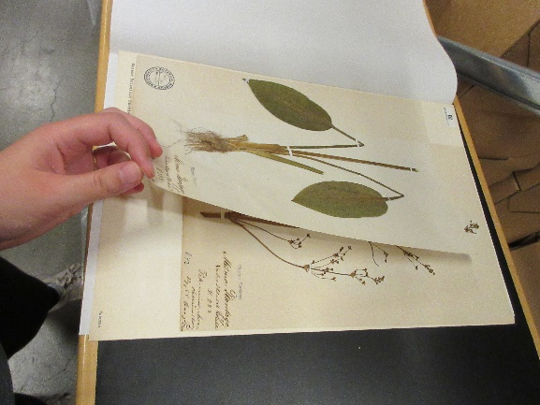

* 1. Any type of folded sheets that show more than one label with the **different** information, when folded.
     1. Barcode: corresponding to label information
     2. Flag as: MSO
     3. Check box: Specimen Obscured (only note on specimen(s) NOT showing on the front page)
     4. Image: as MSO-sheet.

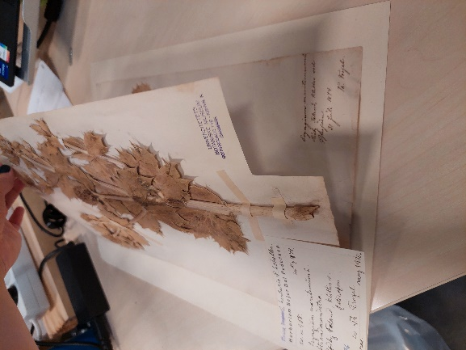

* 1. Folded sheets with specimens on both sides of the sheet.
     1. Barcode: 1
     2. Flag as: Single
     3. Check box: Specimen and/or Label obscured
     4. Image: front page only (even if no specimen is showing)

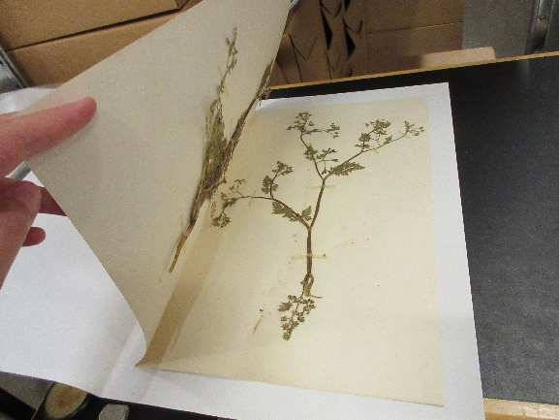

* 1. 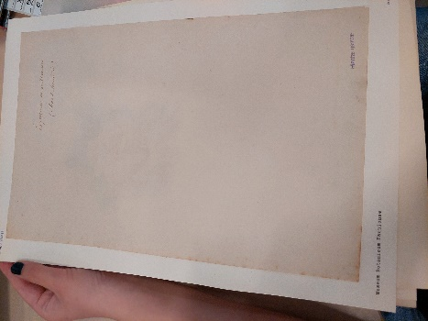Fold overs with information on the front and plant on the inside
     1. Barcode: corresponding to label information
     2. Flag as: corresponding to the label information
     3. Check box: Specimen obscured
     4. Image: Front page only

1. **Multi Object Specimen (MOS):** A specimen that stretches over multiple sheets. Often clamped/clipped together.

**Barcode**

* Flag as MOS in the app[2]
* Remove the clamp/clip
* Give every sheet a barcode, flag them as MOS and register additional information in the app as usual.
* Do not clamp/clip the sheets back together but note in the far right corner “sheet number / sheets in total” (ex. 1/3, 2/3, 3/3)

**Image**

* Regular MOS do not have any shapes assigned to them.
* Image as regular sheets.

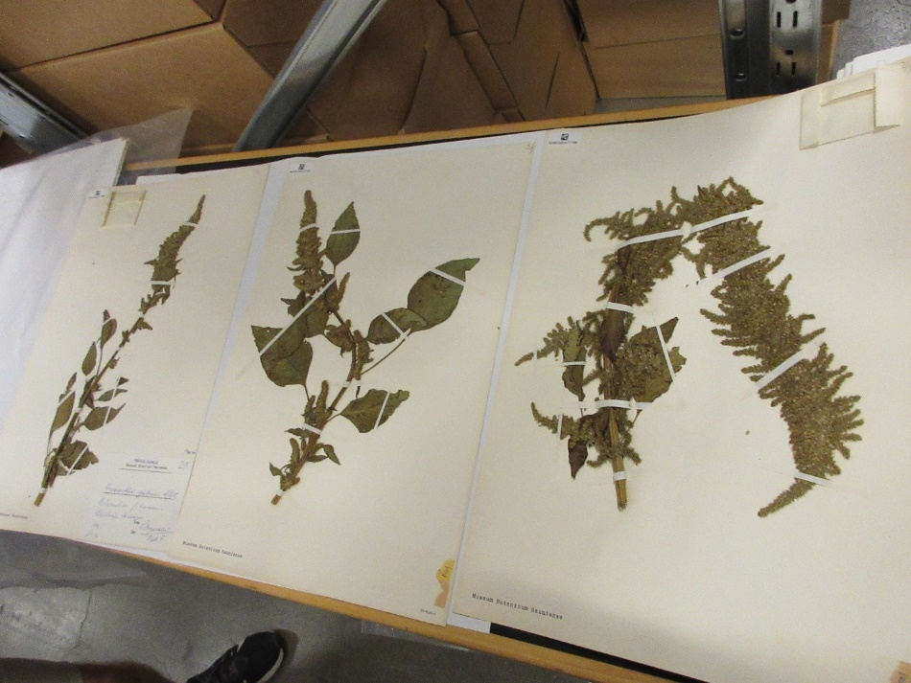

1. **Multi Specimen Object (MSO):** A sheet that contains multiple collections. A sheet can have more specimens on it WITHOUT being a MSO and multiple labels do not necessarily means multiple specimens. The indicators for MSO are:

* Multiple dates
* Multiple locations
* Multiple collectors

**OBS!** Two names does not necessarily mean two collectors. If a name has “det.” written next to it, this is simply the name of the person who determined the species of the plant. This can occur many times on same sheet.

The same is relevant when looking at dates. Make sure that the dates indicates date of collecting and not date of determine.

**Barcode**

* Flag as MSO in the app
* Assign barcodes corresponding to the number of species on the sheet (determined by assessing the labels as above).
* Place barcodes in the top left corner.

It is important to indicate which barcodes are assigned to which specimens. Assign each specimen with its number/letter under its barcode (PENCIL ONLY). See below (3.1.) how to handle MSO where the specimens does not have numbers/letters assigned to them.

**Image**

* When imaging MSO we use data matrices to visually and digitally connect the images. These data matrices consists of a label barcode (L-BC) used for all MOS-records and a disposable barcode (D-BC) unique for every individual MOS-encounter.

1. image the sheet(s) containing the label(s) with the L-BC immediately below the ruler and D-BC below that
2. Now remove the L-BC and image each following specimen sheet with the same D-BC
3. Finally throw away the D-BC specific to this case.
   1. MSO that doesn’t clearly state what specimen belongs to which label
      1. Barcode: corresponding to numbers of labels
      2. Flag as: MSO
      3. Assign the barcode to the labels by adding pencil numbers next to the labels and under the barcode.
      4. Image: as normal

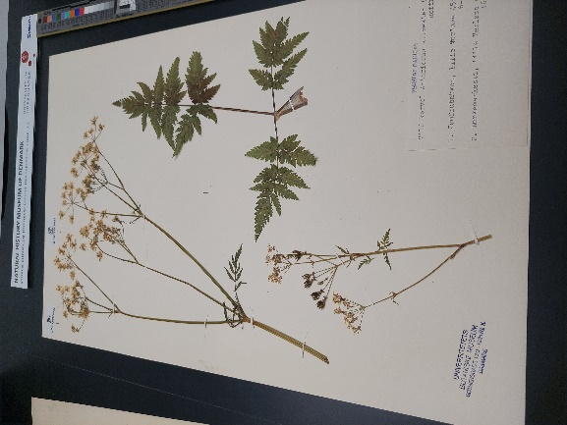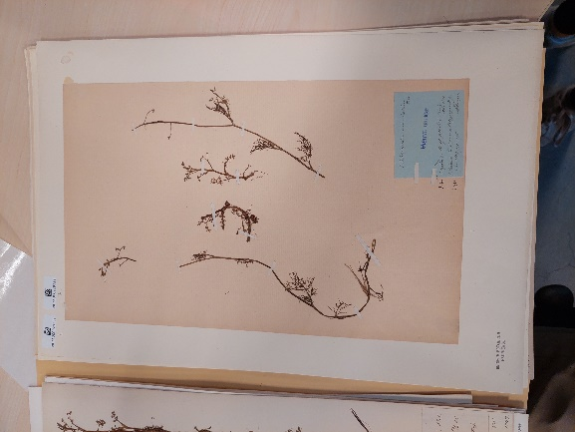

1. **Non-visible specimens** 
   1. Capsules
      1. DO NOT open the capsule!
      2. Barcode: corresponding to label information
      3. Flag as: corresponding to label information
      4. Check box: Specimen Obscured
      5. Image: as a regular sheet

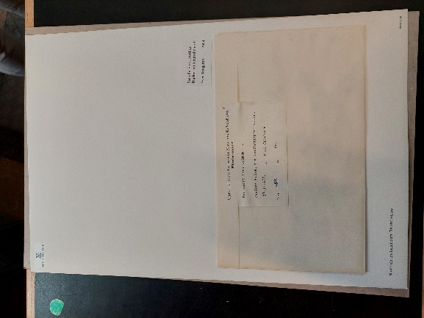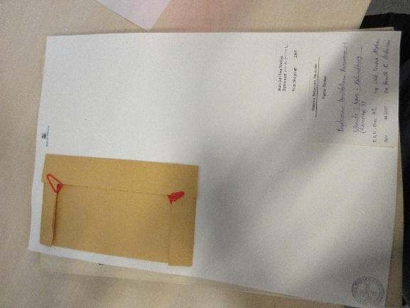

* 1. Photos/drawings with data
     1. Barcode: corresponding to label information
     2. Flag as: corresponding to label information
     3. Notes: Non-botanical object

Image: as a regular sheet

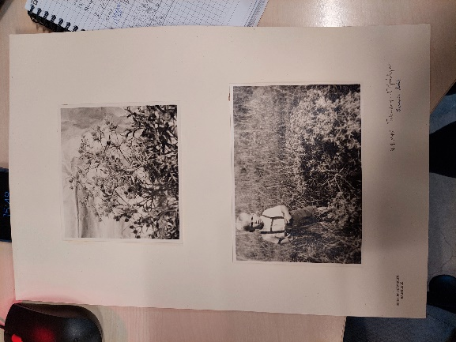

* 1. Photos/drawings without data
     1. Do not barcode or image
     2. Keep in the collection
  2. Missing Specimen
     1. Barcode: corresponding to label information
     2. Flag as: corresponding to label information
     3. Check box: Specimen Obscured
     4. Image: as a regular sheet

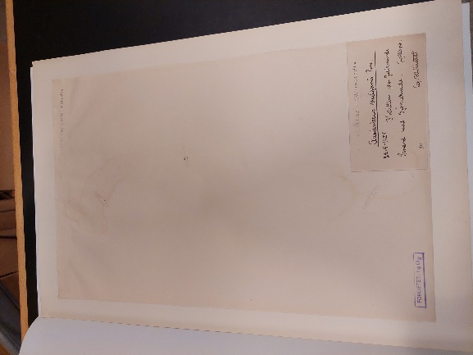

1. Species that need remounting
   1. Damaged or loose specimens: Exercise caution and handle VERY carefully!
      1. Barcode: corresponding to label information
      2. Flag as: corresponding to label information + check off the ‘’damaged specimen” box
      3. Image: As regular, sheet, but VERY carefully.
   2. Two different species on one sheet: If just **one** of them matches the folder info then treat as normal specimen otherwise contact collections manager.
      1. Barcode: corresponding to label information
      2. Flag as: corresponding to label information + check off the ‘’damaged specimen” box
      3. Number of barcodes: only give barcode to the correct species.
   3. Loose fragments
      1. Exercise caution and handle very carefully
      2. If a capsule is present at the sheet place larger fragments into this.
      3. If a capsule is not present, take care to maintain association of the fragments with the specimen.
      4. Flag as: check off the ‘’damaged specimen” box
      5. Notes: “Loose fragment(s)”
      6. Image as usual
2. **Active (living) pest and or pest damage.**
   * 1. **Conceal the sheet in a plastic bag.**
     2. **Alert Collections Managers immediately!**

1. As long as the pages are glued/stapled together it’s never a MOS
2. When flagging as MOS the specimen gets a container number assigned. Remember to unflag when the MOS ends. If you encounter two MOS in a row, change the number by flag, unflag and flag again to create a new container number.